Assignment-17.3:

Write a mapreduce job that takes configuration from command line (min.word.count). Based on the configuration, it should perform count of words from a document and produce only those words in the output whose count is greater than or equal to the configuration.

Main Class:

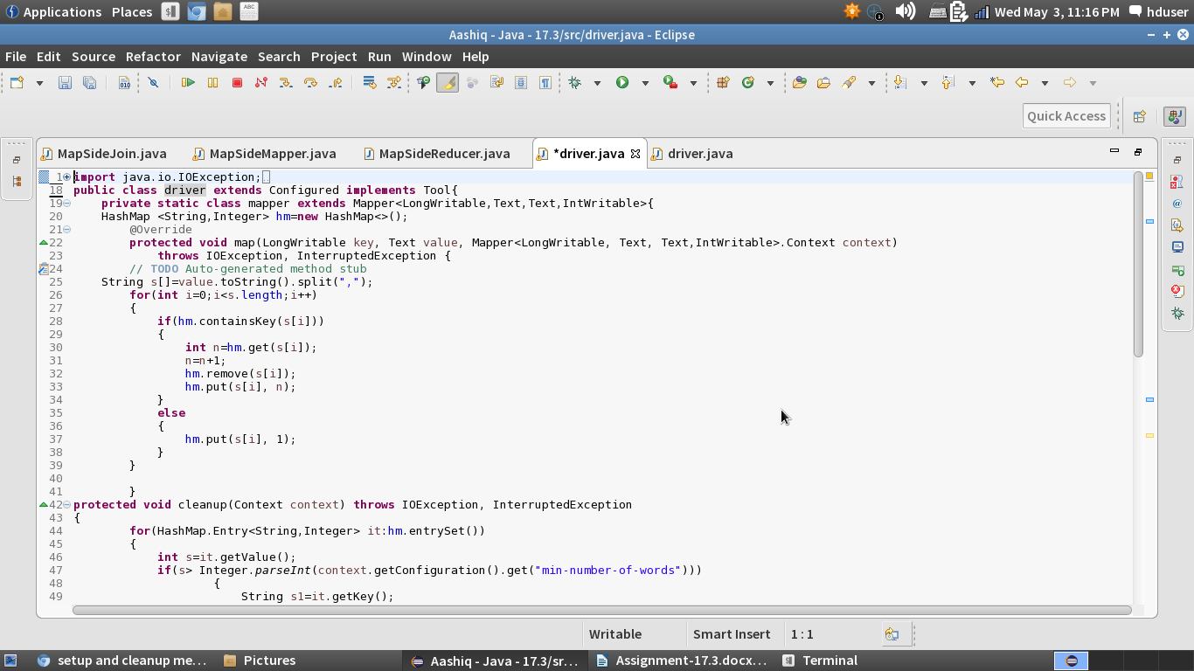

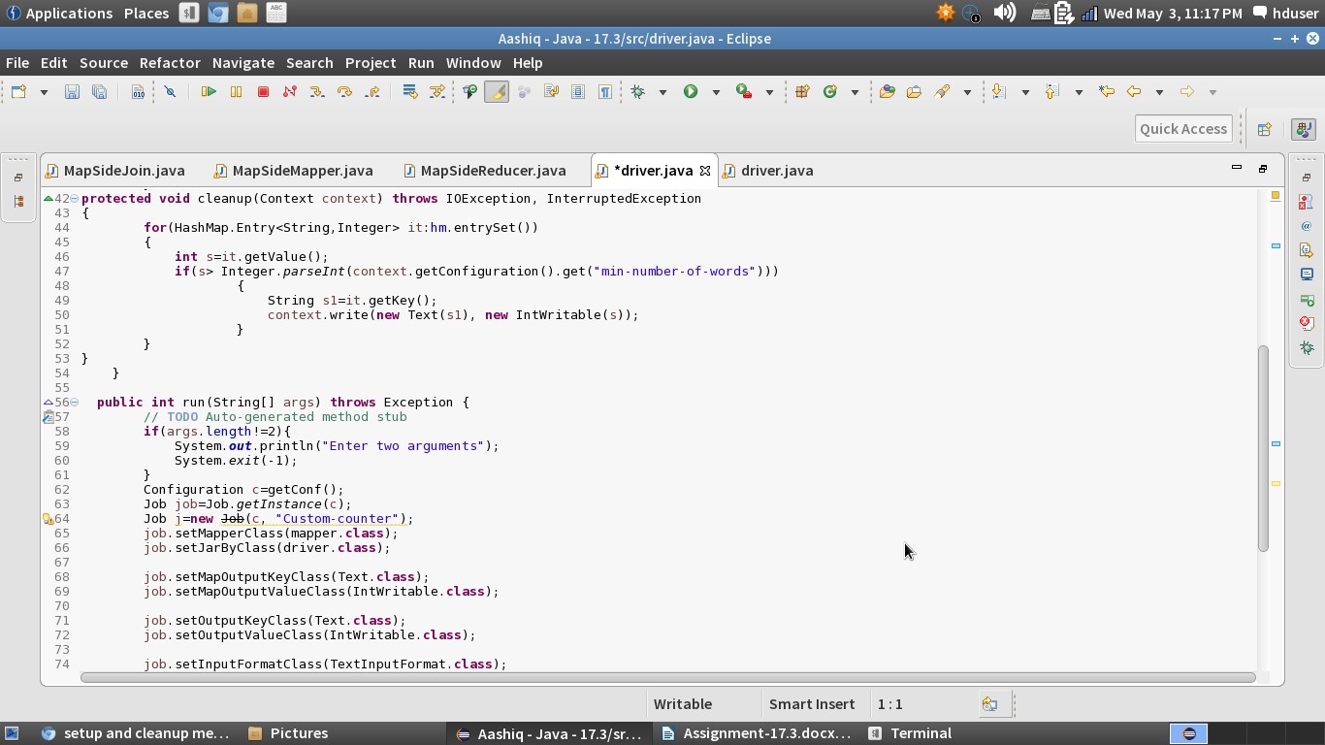

In the line 47, we are setting the dynamic configuration.

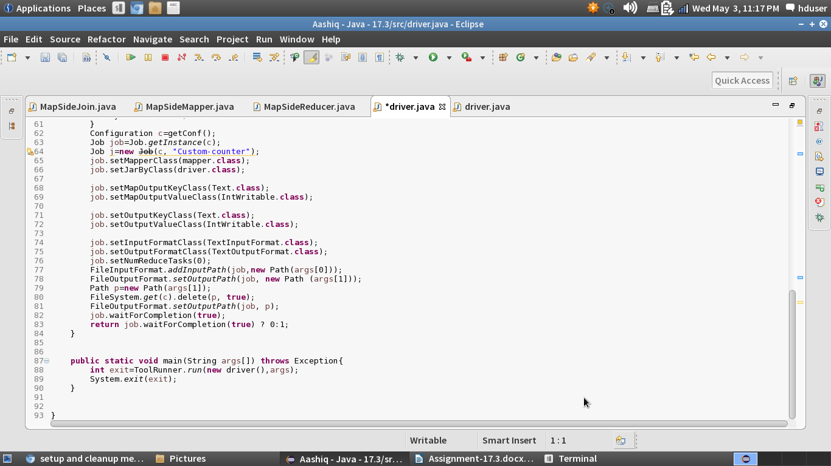

Running the Jar File:

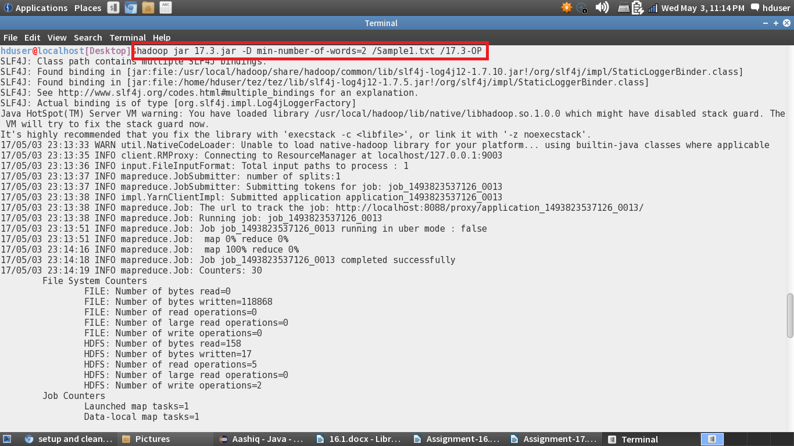

Input Text File:

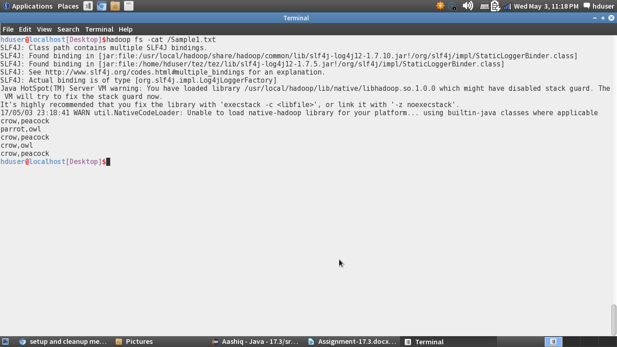

Output File:

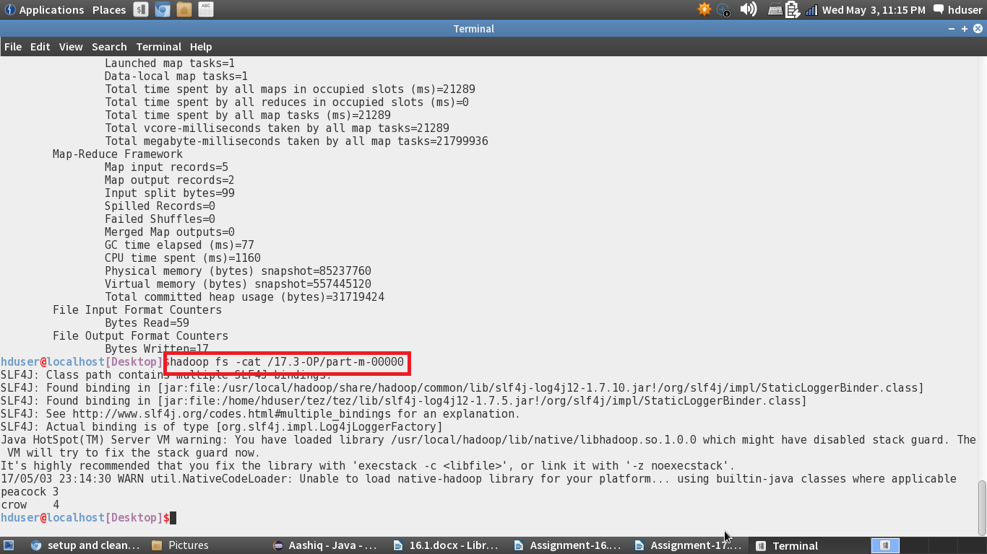

In the above screenshot, the words which are present more than twice are displayed.